EMAIL SIGNATURES
Email is a primary communication tool for so many. It is important that your colleagues throughout our system know who you are and how to contact you. When you send an email, a signature lets the receiver know what department you work in and your title.
In addition, uniform email signatures deliver brand consistency electronically across UofL Health. Just as our business cards and letterhead uphold an identity standard, email signatures should follow a similar conventional style.
The signature below was designed to project a distinct UofL Health identity and to achieve consistency in our communications, both internally and externally. Email signatures present essential information, such as contact details, for the convenience of those with whom the staff is communicating.
Email signature guidelines:
- The only font you should use in your email signature is Arial. Your name should be in 12-point font, everything else should be in 10-point font.
- You may only use one logo--the UofL Health logo.
- Absolutely no other URLs, logos, emblems, sayings or quotes are permitted.
- Email signatures should also be set when sending correspondence from your mobile device. The logo, in this instance, isn’t necessary.
- Email address, cell phone and fax numbers are optional.
- Please include your email signature on all new emails as well as replies/forwards.
***
Copy and paste the following for your email signature. Then personalize for your use.
Name Last Name
Title/Position
Department Name
Facility/Entity
O: 502-000-0000
C: 502-000-0000
F: 502-000-0000
UofLHealth.org

How to make an email signature on Outlook (desktop):
The following are steps to creating an email signature in Outlook mail from the desktop app:
- Open the Outlook desktop app (it is a blue icon that looks like a letter).
- Once Outlook is open, you should see all of your email communications, in addition to a toolbar at the top.
- On the toolbar, select “File” which is located in the top-left corner of the screen. Your screen should look like this:
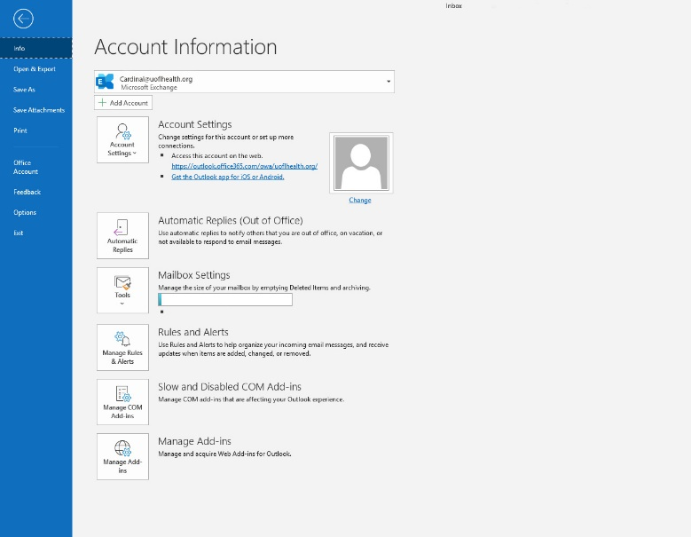

- On the left-hand side, click the “Options” tab. This will open a pop-up box entitled “Outlook Options.”
- On the left-hand side, there are different tabs for different options you can edit to suit your email needs. You want to select “Mail.”
- Under the “Mail” tab, you should have the options below:
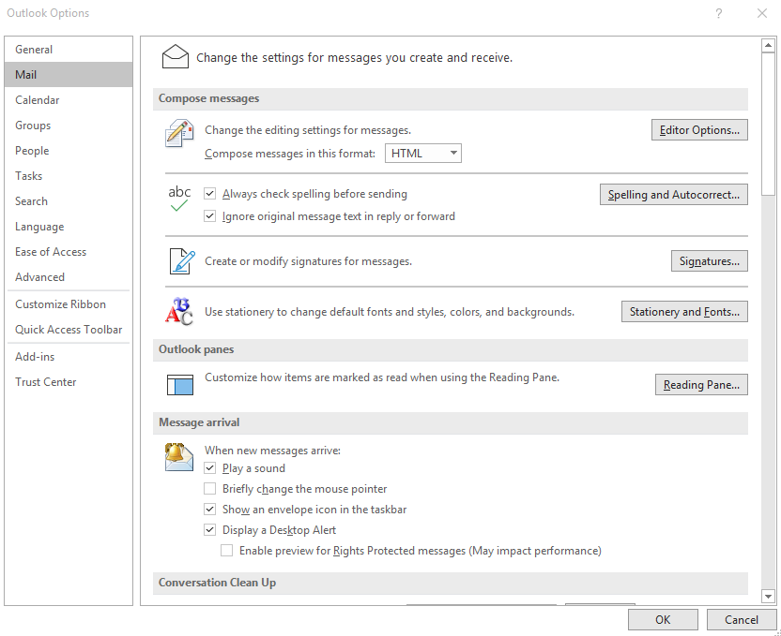

- Select the “Signature” box (it is circled in the above photo).
- Copy and paste the below text into the text box:

Name Last Name
Title/Position
Department Name
Facility/Entity
O: 502-000-0000
C: 502-000-0000
F: 502-000-0000
UofLHealth.org
Be sure to personalize the fields to reflect the correct information.
- Under “Choose default signature,” make sure the new message field says “Mine” as well as the replies/forwards field.
- Once you have finished updating your signature, select “OK.”
- To make sure the signature has been updated, open up a new email message. Your signature should be automatically inserted into the email message.

